|  |  |  |
| --- | --- | --- |
|  | October First Thursday Match  **Stage 2**  **Memory Hole**  Designed by Harley Wiegert Georgia Practical Sporting League |  |
| **START POSITION:** Standing in either left or right box with both feet.  **HANDGUN:** Handgun is loaded and holstered, wrists below belt.  **PCC:** PCC is loaded, stock on belt, muzzle pointed downrange. | | **SCORING:** Comstock, 22 rounds, 110 points  **TARGETS:** 11 USPSA paper targets  **SCORED HITS:** 2 Best hits per target will be scored  **START-STOP:** Audible - Last shot  **RULES:** Current USPSA Rules |
| **STAGE PROCEDURE:** Engage targets from within the shooting area. | |

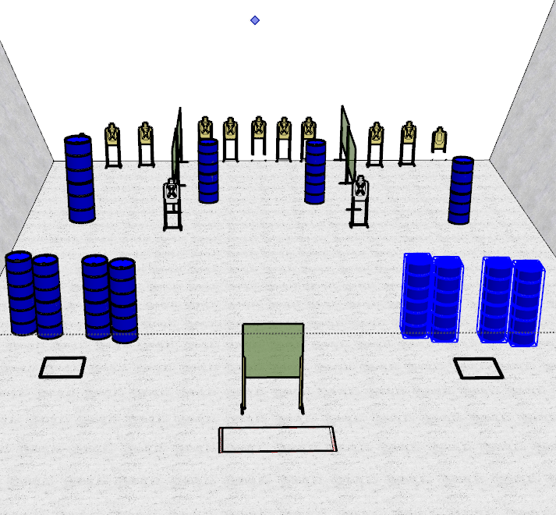

**WRITTEN STAGE BRIEFING:**

**Stage 2 – Memory Hole** is a 22-round, 110 point, Comstock Long Course. There are 11 USPSA targets and the best 2 hits per target will be scored.

**Handgun start position** is standing with both feet in either the left or right shooting box with wrists below belt. The handgun is loaded and holstered.

**PCC start position** is standing with both feet in either the left or right shooting box. PCC is loaded, held in both hands with muzzle pointed downrange.

On the audible start signal, engage targets from within the shooting areas.